WEEK 1
What is a Neural Network?
Question
True or false? As explained in this lecture, every input layer feature is interconnected with every hidden layer feature.
True

Supervised Learning with Neural Networks
Question
Would structured or unstructured data have features such as pixel values or individual words?
Unstructured data

Why is Deep Learning taking off?
Question
What will the variable m denote in this course?
Number of training examples

Frequently Asked Questions
Congratulations to be part of the first class of the Deep Learning Specialization! This form is here to help you find the answers to the commonly asked questions. We will update it as we receive new questions that we think are important for all learners.
General Questions
Q: I have an idea that would improve the course content. What can I do? A: You can put it in Discourse as "New ideas for the course". Our staff or mentors will take notice. Thanks a lot.
Q: The audio in the videos is quite bad sometimes, muffled or low volume. Please fix it. A: You can mitigate the audio issues by turning down the bass and up the treble if you have those controls, or using a headset, which naturally emphasizes the higher frequencies. Also you may want to switch on the English closed captioning. Of course, we are working everyday to improve the quality of the videos and avoid anything that can affect your learning.
Q: What does it mean when I see “Math Processing Error?” A: The page is attempting to use MathJax to render math symbols. Sometimes the content delivery network can be sluggish or you have caught the web page Ajax javascript code in an incomplete state. Normally just refreshing the page to make it load fully fixes the problem.
Q: The video quality is bad? A: You could click the settings option in the video and upgrade the quality to High. (recommended if you have a good internet connection)
Q: Is there a prerequisite for this course? A: Students are expected to have the following background:
- Very basic programming skills (i.e. ability to import libraries, create variables, functions, lists, dictionaries and for loops)
- Familiarity with basic machine learning (how do we represent a dataset as a matrix, etc.).
- Familiarity with the basic linear algebra (matrix multiplications, vector operations etc.).
Q: Why do we have to use Python? A: Python is an open-source language, anyone can use it from anywhere in the world. It is widely used in academics (research labs) or in the industry. It has a useful library "Numpy" that makes math operations very easy. Python has several deep learning frameworks running on top of it (Tensorflow, Keras, PaddlePaddle, CNTK, Caffe, ...) and you are going to learn some of them. It is also easy to learn. Furthermore, we believe Python has a good future, as the community is really active and builds amazing stuff.
Q: Has anyone figured out the how to solve this problem? Here is my code [Insert code]. A: This is a violation of the Coursera Honor Code.
Q: I've submitted correct answers for [insert problem]. However I would like to compare my implementation with other who did correctly. A: This is a violation of the Coursera Honor Code.
Q: This is my email: [insert email]. Can we get the answer for the quiz? A: This is a violation of the Coursera Honor Code.
Q: Do I receive a certificate once I complete this course? A: Course Certificate is available in this course.
Q: What is the correct technique of entering a numeric answer to a text box question ? A: Coursera's software for numeric answers only supports '.' as the decimal delimiter (not ',') and require that fractions be simplified to decimals. For answers with many decimal digits, please use a 2 digits after decimal point rounding method when entering solutions if not mentioned in the question.
Q: What is the correct technique of entering a 1 element matrix ? A: They should be entered as just the element without brackets.
Q: What does a A being a 3 element vector or a 3 dimensional vector mean? A: If not described a vector as mentioned in the questions is $A=\left[\begin{aligned}element1 \\ element2 \\ element3\end{aligned}\right]$
Q: I think I found an error in a video. What should I do? Post it in Discourse. We will try to implement your feedback as soon as possible.
Q: My quiz grade displayed is wrong or I have a verification issue or I cannot retake a quiz. What should I do? A: Contact learner support. These queries can only be resolved by learner support and it is best if they are contacted directly. Do not flag such issues.

Week 1 Quiz
Question 1
Which of the following are some aspects in which AI has transformed business?
Web searching and advertisement.
Nice work
Yes. AI has helped to make a fit between services or results and consumers or queries.
1 / 1 point

Question 2
Which of the following are reasons that didn't allow Deep Learning to be developed during the '80s?
Limited computational power.
Nice work
Yes. Deep Learning methods need a lot of computational power, and only recently the use of GPUs has accelerated the experimentation with Deep Learning.
Interesting applications such as image recognition require large amounts of data that were not available.
Nice work
Yes. Many resources used today to train Deep Learning projects come from the fact that our society digitizes almost everything, creating a large dataset to train Deep Learning models.
0.8 / 1 point

Question 3
Recall this diagram of iterating over different ML ideas. Which of the statements below are true? (Check all that apply.)
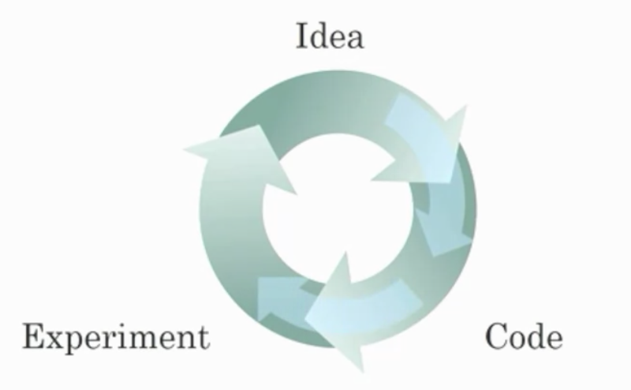
Improvements in the GPU/CPU hardware enable the discovery of better Deep Learning algorithms.
Nice work
Yes. By speeding up the iterative process, better hardware allows researchers to discover better algorithms.
Better algorithms can speed up the iterative process by reducing the necessary computation time.
Nice work
Yes. Recall how the introduction of the ReLU activation function helped reduce the time needed to train a model.
1 / 1 point

Question 4
When experienced deep learning engineers work on a new problem, they can usually use insight from previous problems to train a good model on the first try, without needing to iterate multiple times through different models. True/False?
False

Nice work
Yes. Finding the characteristics of a model is key to having good performance. Although experience can help, it requires multiple iterations to build a good model.
1 / 1 point

Question 5
Which of the following depicts a Sigmoid activation function?

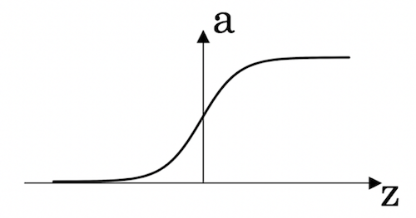

Nice work
Correct! This is the sigmoid activation function; this function was changed for the ReLU activation function helping with the training of NN.
1 / 1 point

Question 6
Which of the following are examples of unstructured data? Choose all that apply.
Sound files for speech recognition.
Nice work
Yes, audio is an example of "unstructured" data.
Information about elephants’ weight, height, age, and the number of offspring.
Text describing size and number of pages of books.
Images for bird recognition.
Nice work
Yes, images are an example of "unstructured" data.
You didn't select all the correct answers
0.8 / 1 point

Question 7
Which of the following are examples of structured data? Choose all that apply.
A dataset with zip code, income, and name of a person.
Nice work
Yes, this data can be presented in a table. This is an example of "structured" data.

A dataset of weight, height, age, the sugar level in the blood, and arterial pressure.
Nice work
Yes, this data can be presented in a table. This is an example of "structured" data.
1 / 1 point
8.
Question 8
Why is an RNN (Recurrent Neural Network) used for machine translation, say translating English to French? (Check all that apply.)
It is applicable when the input/output is a sequence (e.g., a sequence of words).
Nice work
Yes. An RNN can map from a sequence of english words to a sequence of french words.
0.5 / 1 point

Question 9
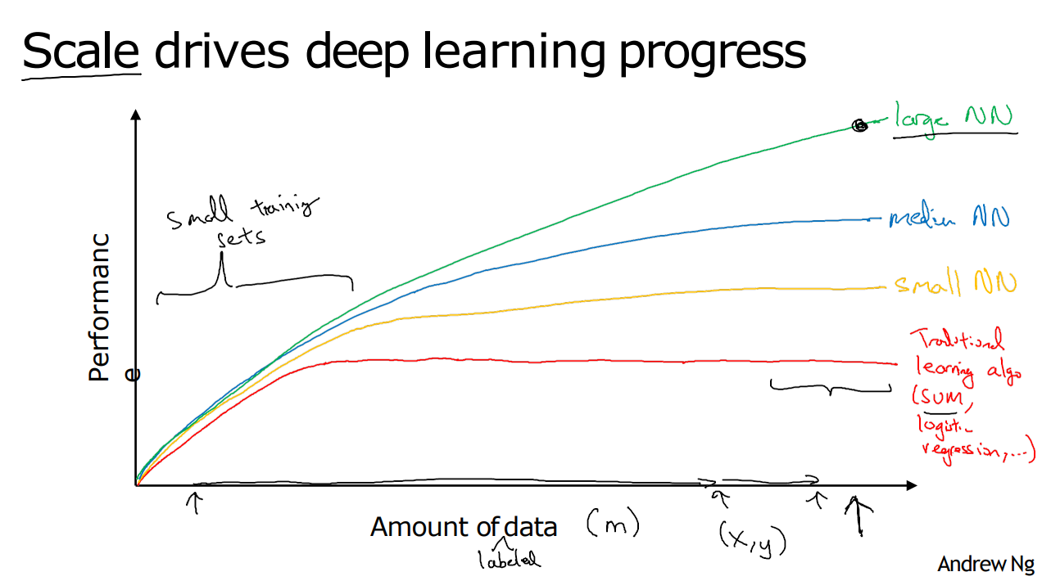
From the given diagram, we can deduce that Large NN models are always better than traditional learning algorithms. True/False?
False
Nice work
Yes, when the amount of data is not large the performance of traditional learning algorithms is shown to be the same as NN.
1 / 1 point

Question 10
Assuming the trends described in the previous question's figure are accurate (and hoping you got the axis labels right), which of the following are true? (Check all that apply.)
Increasing the size of a neural network generally does not hurt an algorithm’s performance, and it may help significantly.
Nice work
Yes. According to the trends in the figure above, big networks usually perform better than small networks.

WEEK 2
Logistic Regression Question:
What are the parameters of logistic regression?
W, an $n_{x}$ dimensional vector, and b, a real number.

Logistic Regression Cost Question
What is the difference between the cost function and the loss function for logistic regression?
The loss function computes the error for a single training example; the cost function is the average of the loss functions of the entire training set.

Gradient Descent Question
True or false. A convex function always has multiple local optima.
False

Derivatives Question
On a straight line, the function's derivative...
doesn't change.

Computation Graph Question
One step of ________ propagation on a computation graph yields derivative of final output variable.
Backward

Derivatives with a Computation Graph Question
In this class, what does the coding convention dvar represent?
The derivative of a final output variable with respect to various intermediate quantities.

Logistic Regression Gradient Descent Question
In this video, what is the simplified formula for the derivative of the losswith respect to z?
a - y

Gradient Descent on m Examples Question
In the for loop depicted in the video, why is there only one dw variable (i.e. no i superscripts in the for loop)?
The value of dw in the code is cumulative.

Derivation of DL/dz (Optional)
Derivation of $\frac{dL}{dz}$
If you're curious, you can find the derivation for $\frac{dL}{dz}=a-y$ in this Discourse post "Derivation of DL/dz"
Remember that you do not need to know calculus in order to complete this course or the other courses in this specialization. The derivation is just for those who are curious about how this is derived.

Vectorization Question
True or false. Vectorization cannot be done without a GPU.
False

Vectorizing Logistic Regression Question
What are the dimensions of matrix X in this video?
($n_{x}$,m)

Vectorizing Logistic Regression's Gradient Output Question
How do you compute the derivative of b in one line of code in Python numpy?
1 / m*(np.sum(dZ))

Broadcasting in Python Question
Which of the following numpy line of code would sum the values in a matrix A vertically?
A.sum(axis = 0)

A Note on Python/Numpy Vectors Question
What kind of array has dimensions in this format: (10, ) ?
A rank 1 array

Explanation of Logistic Regression Cost Function (Optional) Question
True or False: Minimizing the loss corresponds with maximizing logp(y|x).
True

WEEK 2 QUIZ
Question 1
In logistic regression given the input $x$, and parameters $w∈R^{n_{x}}$ , $b∈R$, how do we generate the output $\hat{y}$?
$$σ(W x+b)$$
Nice work
Right, in logistic regression we use a linear function $Wx+b$ followed by the sigmoid function $σ$, to get an output $y$ such that $0<\hat{y}<1$.
1 / 1 point

Question 2
Suppose that $\hat{y}=0.5$ and $y=0$. What is the value of the "Logistic Loss"? Choose the best option.
0.693
Nice work
Yes. Given the values of $\hat{y}$ and $y$ we get $L(0.5,0)=-\left(0 log⁡0.5+1 log⁡(0.5)\right)≈0.693$.
1 / 1 point

Question 3
Consider the Numpy array $x$:
$$x=np.array([[[1],[2]],[[3],[4]]])$$
What is the shape of x?
(2,2,1)
Nice work
Yes. This array has two rows and in each row it has 2 arrays of 1x1.
1 / 1 point

Question 4
Consider the following random arrays $a$ and $b$, and $c$:
$a=np.random.randn(3,4)$ # $a.shape=(3,4)$
$b=np.random.randn(1,4)$ # $b.shape=(1,4)$
$$c=a+b$$
What will be the shape of $c$?
c.shape = (3, 4)
Nice work
Yes. Broadcasting is used, so row b is copied 3 times so it can be summed to each row of a.
1 / 1 point

Question 5
Consider the two following random arrays $a$ and $b$:
$a=np.random.randn(4,3)$# $a.shape=(4,3)$
$b=np.random.randn\left(3,2\right)$# $b.shape=(3,2)$
$c=a*b$
What will be the shape of $c$?
The computation cannot happen because the sizes don't match. It's going to be "Error"!
Nice work
Indeed! In numpy the "*" operator indicates element-wise multiplication. It is different from "np.dot()". If you would try "c = np.dot(a,b)" you would get c.shape = (4, 2).
1 / 1 point

Question 6
Suppose you have $n_{x}$ input features per example. If we decide to use row vectors $x_{j}$ for the features and $X=\left[\begin{aligned}x_{1} \\ x_{2} \\ ⋮ \\ x_{m}\end{aligned}\right]$
What is the dimension of $X$?
$$\left(m , n_{x}\right)$$
Nice work
Yes. Each $x_{j}$ has dimension $1×n_{x}$ $,X$ is built stacking all rows together into a $m×n_{x}$ array.
1 / 1 point

Question 7
Consider the following array:
$$a=np.array([[2,1],[1,3]])$$
What is the result of $a*a$?
The computation cannot happen because the sizes don't match. It's going to be an "Error"!
$$\left(\begin{matrix}4 & 2 \\ 2 & 6\end{matrix}\right)$$
$$\left(\begin{matrix}5 & 5 \\ 5 & 10\end{matrix}\right)$$
$$\left(\begin{matrix}4 & 1 \\ 1 & 9\end{matrix}\right)$$
Try again
No, recall that * indicates element-wise multiplication, not matrix multiplication.
0 / 1 point

Question 8
Consider the following code snippet:
$a.shape=(3,4)$a, point, s, h, a, p, e, equals, left parenthesis, 3, comma, 4, right parenthesis
$b.shape=(4,1)$b, point, s, h, a, p, e, equals, left parenthesis, 4, comma, 1, right parenthesis
for i in range(3):
for j in range(4):
c[i][j] = a[i][j] + b[j]
How do you vectorize this?
c = a + b.T
Nice work
1 / 1 point

Question 9
Consider the following arrays:
$$a=np.array([[1,1],[1,-1]])$$
$$b=np.array([[2],[3]])$$
$c=a+b$c
Which of the following arrays is stored in $c$c?
$\begin{matrix}3 & 3 \\ 4 & 2\end{matrix}$
Nice work
Yes. The array b is a column vector. This is copied two times and added to the array a to construct the array c.
1 / 1 point

Question 10
Consider the following computational graph.
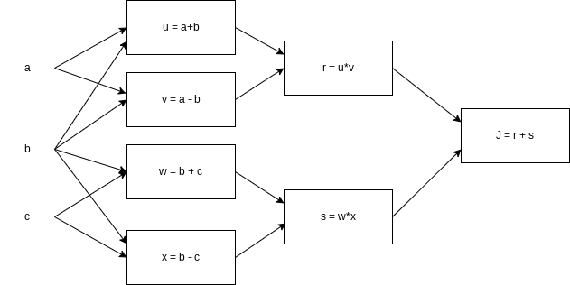
What is the output of J?
$$a^{2}-c^{2}$$
Nice work
Yes. $J=r+s=u*v+w*x=(a+b)*(a-b)+(b+c)*(b-c)=a^{2}-b^{2}+b^{2}-c^{2}=a^{2}-c^{2}$

Programming Assignment FAQ
Please note that when you are working on the programming exercise you will find comments that say "# GRADED FUNCTION: functionName". Do not edit that comment. The function in that code block will be graded.
1) What is a Jupyter notebook?
A Jupyter notebook is a document that allows you to have executable code and text in the same web-page. With Jupyter notebooks you do not have to download anything on your computer to do the programming exercises. Everything is provided for you online. You will be completing the exercise as you scroll down the webpage without having to jump between different files.
2) What is the coursera hub?
The coursera hub is the workspace which contains the notebook, helper files, data sets, and images. To go to the hub, you should first be in the notebook:
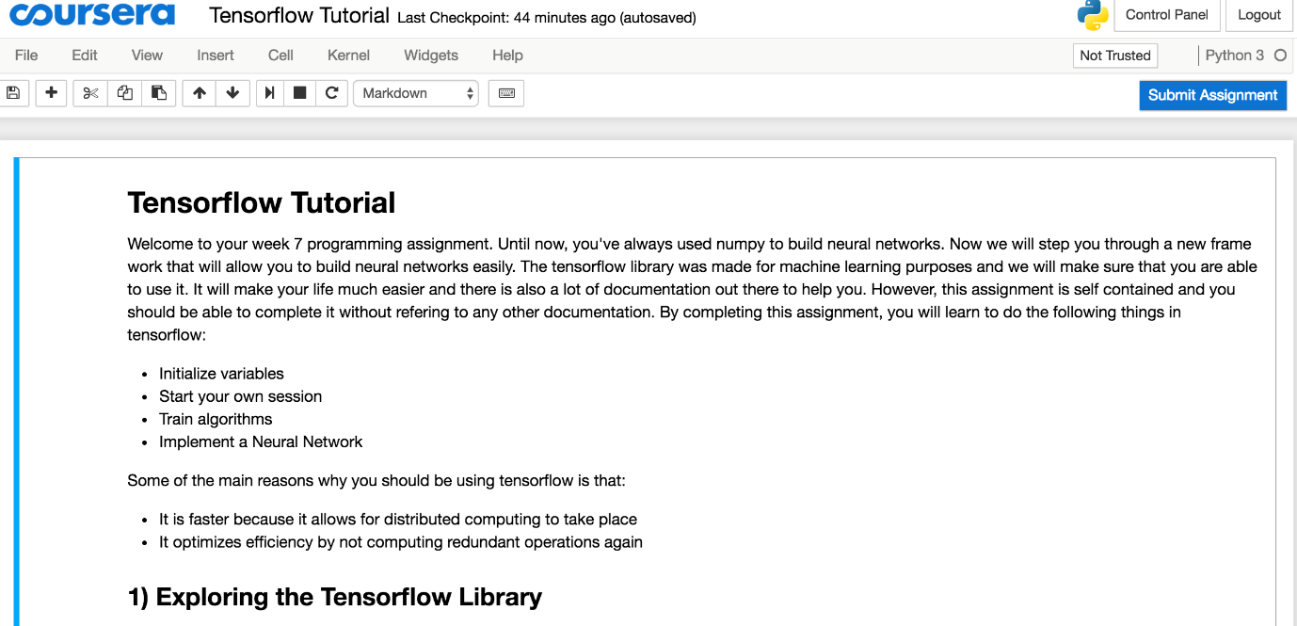
Click on File ==> Open as shown below:
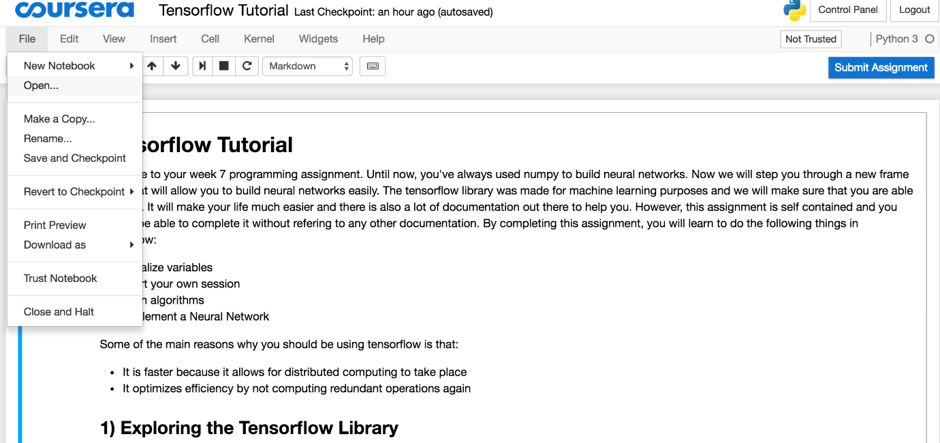
This will lead you to an environment that has all your programming exercises and datasets. You should go there to check out any helper functions that we have provided for you.
3) How do I submit my assignment?
To submit the assignment, click on the blue button in the above image labelled "Submit Assignment."
4) How do I run a cell?
To run a cell, click on the cell and press Shift & Enter. You could also run the cell (or cells) by going to Cell and selecting one of the options:
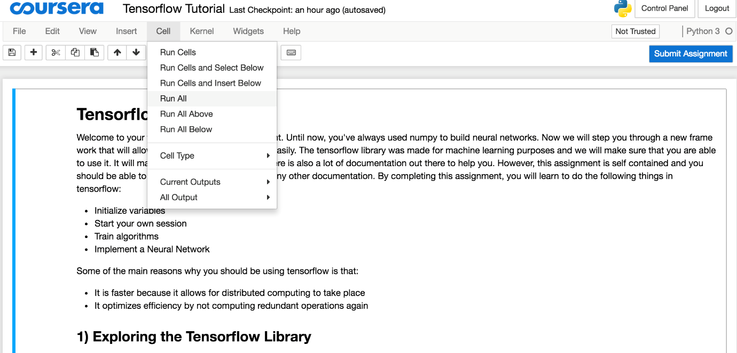
5) What is a kernel?
You could think of the kernel as the core of the Jupyter notebook's operating system. Sometimes if the notebook blocks or if you want to clear all the variables and start all over again, rather than quitting the notebook and opening it again, you could:
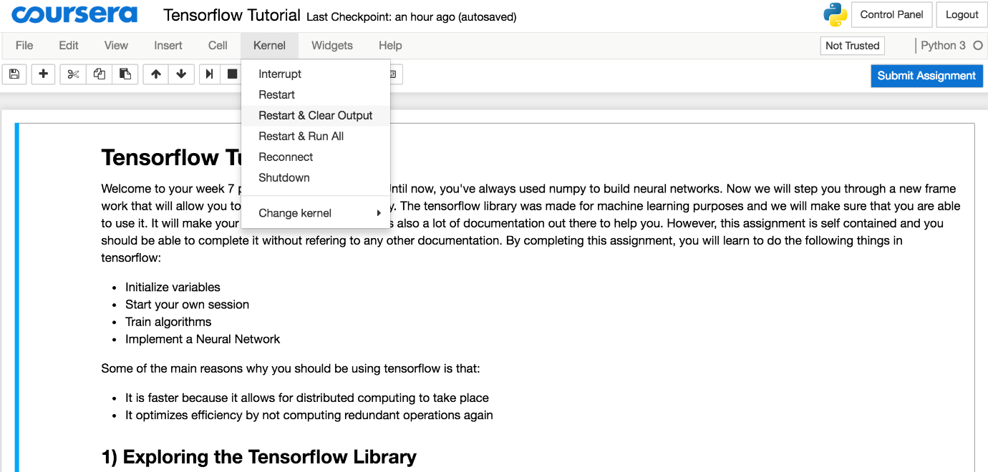
Restart the kernel and clear the output if you accidentally end up in some sort of infinite loop.
6) Why do I get different results every time I run the same cell?
When you run a cell that updates some variable (e.g x: x+1), you will get different results for x as it keeps incrementing. Make sure you are not modifying your existing variables.
7) I got stuck on an assignment; what do I do?
You can post questions and get answers to them from dedicated Mentors in our Forum. Discuss all your queries over there. Please be sure to abide by the course Honor Code.
8) How do I save my progress?
Click on File ==> Save and Checkpoint
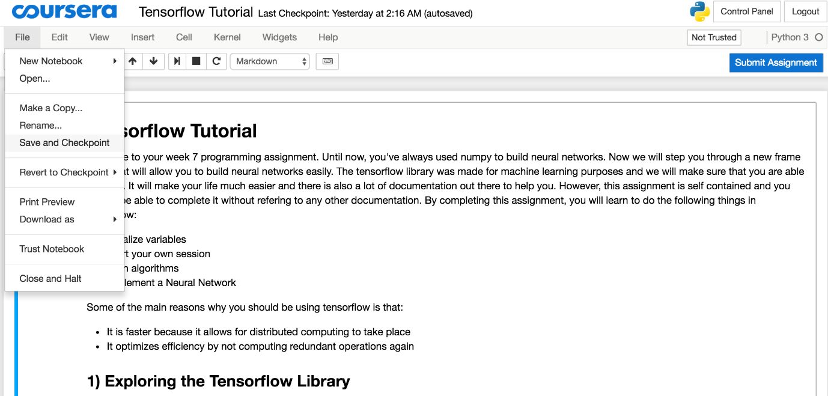
9) What should I do if my jupyter notebook froze?
Just restart the kernel by clicking on Kernel ==> Restart.

(Optional) Downloading your Notebook, Downloading your Workspace and Refreshing your Workspace
This course uses Coursera Labs to provide a notebook environment and to grade your work. There might be some instances where you need to download your notebooks or you wish to download your entire workspace or refresh your workspace to start from scratch. This reading item outlines the steps to do so.
Downloading your Notebook
In case you need to download your notebook for troubleshooting or running in your local environment, you can follow these simple steps:
- From the Menu Bar of the notebook you are working on, click File → Save and Checkpoint to first save your progress.
- Click File → Download as → Notebook (.ipynb). This should start downloading the file into your local machine.
Downloading your Workspace
In case you need to download your entire workspace or some files for troubleshooting, or running in your local environment, you can follow these simple steps:
- From the Menu Bar of the notebook you are working on, click File → Save and Checkpoint to first save your progress.
- Click File → Open... , this will open your workspace.
- On the top right, click Lab Files , this will open a panel.
- Now, you can either download the entire workspace by clicking Download all files or you can select the files you want to download.
Note: The best way to download the supporting files for the notebook(s) is the `Downloading your Workspace` option.
Refreshing your Workspace
This will come in handy whenever you need to start from scratch, fetch the latest version of the assignment, or run into a 404 error.
- Open the notebook from the classroom.
- After the notebook opens up, click File → Open
- When your workspace opens, tick the check box before your notebook file. After it is selected, press Shutdown. The icon beside the filename should turn from green to gray.
- Tick the checkbox again and this time choose Rename and enter any filename other than the original. For example, C1_W1_Assignment.ipynb (original) → C1_W1_Assignment_v2.ipynb
- (Optional) Tick the checkbox of any other file that you want to get a fresh copy of (e.g. dataset files that you might have manipulated irreversibly). Then click Delete . You can also opt to Rename or Download each file individually in case you want to keep them before deleting.
- Click on the Help button on the top right of the page.
- Click the Get latest version button.
- Click the Update Lab button. The page will refresh and you should now see the latest version of the notebook.

WEEK 3
Question 1
Which of the following are true? (Check all that apply.)
- $W^{\left[1\right]}$ is a matrix with rows equal to the parameter vectors of the first layer.
- $w_{3}^{\left[4\right]}$ is the row vector of parameters of the fourth layer and third neuron.
- $w_{3}^{\left[4\right]}$ is the column vector of parameters of the third layer and fourth neuron.
$W^{\left[1\right]}$ is a matrix with rows equal to the transpose of the parameter vectors of the first layer.
Nice work
Yes. We construct $W^{\left[1\right]}$ stacking the parameter vectors $w_{j}^{\left[1\right]}$ of all the neurons of the first layer.
$w_{3}^{\left[4\right]}$is the column vector of parameters of the fourth layer and third neuron.
Nice work
Yes. The vector $w_{j}^{\left[i\right]}$ is the column vector of parameters of the i-th layer and j-th neuron of that layer.
0.8 / 1 point

Question 2
The sigmoid function is only mentioned as an activation function for historical reasons. The tanh is always preferred without exceptions in all the layers of a Neural Network. True/False?
False
Nice work
Yes. Although the tanh almost always works better than the sigmoid function when used in hidden layers, thus is always proffered as activation function, the exception is for the output layer in classification problems.
1 / 1 point

Question 3
Which of the following is a correct vectorized implementation of forward propagation for layer 2?
$$Z^{\left[2\right]}=W^{\left[2\right]} A^{\left[1\right]}+b^{\left[2\right]}$$
$$A^{\left[2\right]}=g(Z^{\left[2\right]})$$
Nice work
Yes. The elements of layer two are represented using a superscript in brackets.
1 / 1 point

Question 4
The use of the ReLU activation function is becoming more rare because the ReLU function has no derivative for $c=0$. True/False?
False
Nice work
Yes. Although the ReLU function has no derivative at $c=0$ this rarely causes any problems in practice. Moreover it has become the default activation function in many cases, as explained in the lectures.
1 / 1 point

Question 5
Consider the following code:
#+begin_src python
x = np.random.rand(3, 2)
y = np.sum(x, axis=0, keepdims=True)
#+end_src
What will be y.shape?
(1, 2)
Nice work
Yes. By choosing the axis=0 the sum is computed over each column of the array, thus the resulting array is a row vector with 2 entries. Since the option keepdims=True is used the first dimension is kept, thus (1, 2).
1 / 1 point

Question 6
Suppose you have built a neural network with one hidden layer and tanh as activation function for the hidden layer. You decide to initialize the weights to small random numbers and the biases to zero. The first hidden layer’s neurons will perform different computations from each other even in the first iteration. True/False?
False
No. Since the weights are most likely different, each neuron will do a different computation.
Nice work
1 / 1 point

Question 7
Logistic regression’s weights w should be initialized randomly rather than to all zeros, because if you initialize to all zeros, then logistic regression will fail to learn a useful decision boundary because it will fail to “break symmetry”, True/False?

False
Nice work
Yes, Logistic Regression doesn't have a hidden layer. If you initialize the weights to zeros, the first example x fed into the logistic regression will output zero but the derivatives of the Logistic Regression depend on the input x (because there's no hidden layer) which is not zero. So at the second iteration, the weights’ values follow x's distribution and are different from each other if x is not a constant vector.
1 / 1 point

Question 8
Which of the following is true about the ReLU activation functions?
They are the go to option when you don't know what activation function to choose for hidden layers.
Nice work
1 / 1 point
9.
Question 9
Consider the following 1 hidden layer neural network:
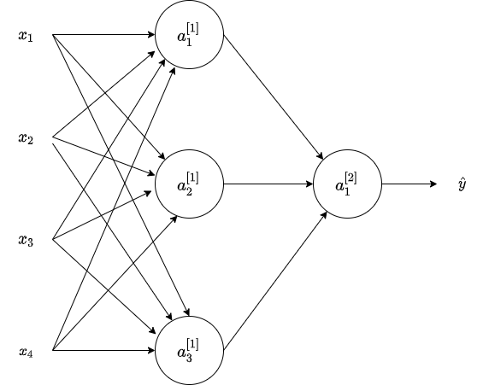
Which of the following statements are True? (Check all that apply).
$b^{\left[1\right]}$ will have shape (3, 1).
Nice work
Yes. $b^{\left[k\right]}$, is a column vector and has the same number of rows as neurons in the k-th layer.
$W^{\left[1\right]}$ will have shape (3, 4).
Nice work
Yes. The number of rows in $W^{\left[k\right]}$ is the number of neurons in the k-th layer and the number of columns is the number of inputs of the layer.
$b^{\left[2\right]}$ will have shape (1,1)
Nice work
Yes. $b^{\left[k\right]}$ is a column vector and has the same number of rows as neurons in the k-th layer.
1 / 1 point

Question 10
What are the dimensions of $Z^{\left[1\right]}$and $A^{\left[1\right]}$?
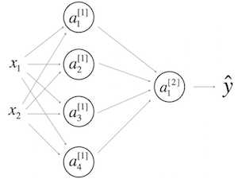
$Z^{\left[1\right]}$ and $A^{\left[1\right]}$ are (4,m)
Nice work

WEEK 4
Optional Reading: Feedforward Neural Networks in Depth
For a more in depth explaination of Feedforward Neural Networks, one of our DLS mentors has written some articles (optional reading) on them. If these interest you, do check them out.
A huge shoutout and thanks to Jonas Lalin!

Clarification For: What does this have to do with the brain?
Note that the formulas shown in the next video have a few typos. Here is the correct set of formulas.
$$dZ^{\left[L\right]}=A^{\left[L\right]}-Y$$
$$dW^{\left[L\right]}=\frac{1}{m}dZ^{\left[L\right]}A^{{\left[L-1\right]}^{T}}$$
$$db^{\left[L\right]}=\frac{1}{m}np.sum(dZ^{\left[L\right]},axis=1,keepdims=True)$$
$$dZ^{\left[L − 1\right]}=W^{{\left[L\right]}^{T}}dZ^{\left[L\right]}*g^{'\left[L − 1\right]}(Z^{\left[L − 1\right]})$$
Note that * denotes element-wise multiplication)
$$⋮$$
$$dZ^{\left[1\right]}=W^{{\left[2\right]}^{T}}dZ^{\left[2\right]}*g^{'\left[1\right]}(Z^{\left[1\right]})$$
$$dW^{\left[1\right]}=\frac{1}{m}dZ^{\left[1\right]}A^{{\left[0\right]}^{T}}$$
Note that $A^{{\left[0\right]}^{T}}$ is another way to denote the input features, which is also written as $X^{T}$
$$db^{\left[1\right]}=\frac{1}{m}np.sum(dZ^{\left[1\right]},axis=1,keepdims=True)$$

WEEK 4 QUIZ
Question 1
False
Nice work
Correct. The "cache" is used in our implementation to store values computed during forward propagation to be used in backward propagation.
1 / 1 point

Question 2
Among the following, which ones are "hyperparameters"? (Check all that apply.)
number of iterations
Nice work
size of the hidden layers $n^{\left[l\right]}$
Nice work
number of layers $L$ in the neural network
Nice work
learning rate $α$
Nice work
1 / 1 point

Question 3
Considering the intermediate results below, which layers of a deep neural network are they likely to belong to?
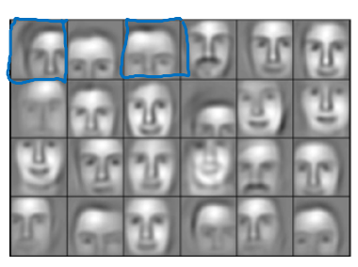
Later layers of the deep neural network.
Nice work
Correct. The deep layers of a neural network are typically computing more complex features such as the ones shown in the figure.
1 / 1 point

Question 4
Vectorization allows you to compute forward propagation in an $L$L-layer neural network without an explicit for-loop (or any other explicit iterative loop) over the layers l=1, 2, …,L. True/False?
False

Question 5
Suppose W[i] is the array with the weights of the i-th layer, b[i] is the vector of biases of the i-th layer, and g is the activation function used in all layers. Which of the following calculates the forward propagation for the neural network with L layers.
for i in range(1, L+1):
Z[i] = W[i]*A[i-1] + b[i]
A[i] = g(Z[i])
Nice work
Yes. Remember that the range omits the last number thus the range from 1 to L+1 gives the L necessary values.
1 / 1 point

Question 6
Consider the following neural network.
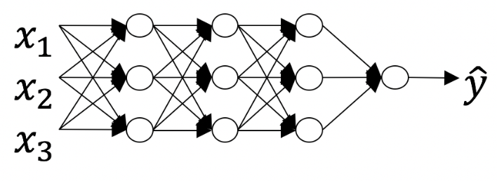
How many layers does this network have?
- The number of layers $L$L is 4. The number of hidden layers is 3.
- The number of layers $L$L is 5. The number of hidden layers is 4.
- The number of layers $L$L is 3. The number of hidden layers is 3.
- The number of layers $L$L is 4. The number of hidden layers is 4.
Try again
No. As seen in lecture, the number of layers is counted as the number of hidden layers + 1. The input and output layers are not counted as hidden layers.
0 / 1 point

Question 7
During forward propagation, in the forward function for a layer $l$ you need to know what is the activation function in a layer (sigmoid, tanh, ReLU, etc.). During backpropagation, the corresponding backward function also needs to know what is the activation function for layer $l$, since the gradient depends on it. True/False?
True
Nice work
Yes, as you've seen in week 3 each activation has a different derivative. Thus, during backpropagation you need to know which activation was used in the forward propagation to be able to compute the correct derivative.
1 / 1 point

Question 8
There are certain functions with the following properties:
(i) To compute the function using a shallow network circuit, you will need a large network (where we measure size by the number of logic gates in the network), but (ii) To compute it using a deep network circuit, you need only an exponentially smaller network. True/False?
True
Nice work
1 / 1 point

Question 9
Consider the following 2 hidden layers neural network:
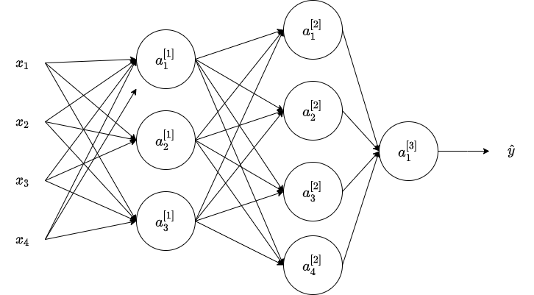
Which of the following statements are true? (Check all that apply).
$W^{\left[1\right]}$ will have shape (3, 4)
Nice work
Yes. More generally, the shape of $W^{\left[l\right]}$ is ($n^{\left[l\right]}$, $n^{\left[l − 1\right]}$).
$W^{\left[2\right]}$ superscript will have shape (4, 3)
Nice work
Yes. More generally, the shape of $W^{\left[l\right]}$ is ($n^{\left[l\right]}$, $n^{\left[l − 1\right]}$).
$b^{\left[1\right]}$ will have shape (3, 1)
Nice work
Yes. More generally, the shape of $b^{\left[l\right]}$ is ($n^{\left[l\right]}$, 1).
1 / 1 point

Question 10
Whereas the previous question used a specific network, in the general case what is the dimension of $b^{\left[l\right]}$, the bias vector associated with layer l?
$b^{\left[l\right]}$ has shape $\left(1 , n^{\left[l\right]}\right)$
Nice work
True. $b^{\left[l\right]}$ is a column vector with the same number of rows as units in the respective layer.

REFERENCES:
Week 2:
- GitHub: Implementing a Neural Network from Scratch in Python – An Introduction (Denny Britz, 2015)
- Why normalize images by subtracting dataset's image mean, instead of the current image mean in deep learning? (Stack Exchange)
Week 3:
- CS231n: Convolutional Neural Networks for Visual Recognition (Stanford University)
Week 4:
Autoreload of modules in IPython (Stack Overflow)

